
Department | FED
Subject | DSA-2
Academic Year
Faculty Name
Student Name
Roll Number
Branch
Course Outcome

Case Study Topic: Delhivery Last-Mile Delivery Optimization
Work Done Summary:
- Modeled the delivery network as a weighted graph.
- Represented the warehouse and customer locations as vertices.
- Applied Held-Karp Dynamic Programming to solve the Travelling Salesman Problem.
- Used bitmasking to represent visited customer subsets.
- Computed the minimum cost path for every subset and ending vertex.
- Evaluated all possible customer visit combinations efficiently.
- Closed the tour by returning to the warehouse.
- Determined the optimal delivery route with minimum travel distance.
Implementation Details:
- Used a distance matrix to store travel distances between locations.
- Represented visited locations using bitmasks.
- Created a DP table: dp[S][v]
where:
- S = subset of visited vertices.
- v = last visited vertex.
- Initialized the warehouse as the starting point.
- Expanded states by adding one unvisited customer at a time.
- Updated minimum costs using dynamic programming transitions.
- After visiting all customers, returned to the warehouse to complete the tour.

Result / Output:
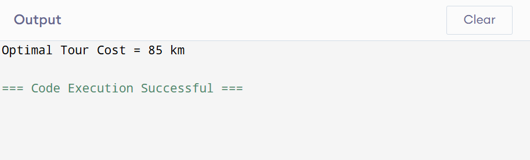

- Held-Karp Dynamic Programming successfully found the shortest closed delivery tour.
- The optimal delivery distance for the given network was 85 km.
- The algorithm reduced the search space from factorial complexity O(n!) to O(n² × 2ⁿ).
- Bitmask-based DP efficiently represented visited customer subsets and avoided redundant computations.
- While suitable for small and medium-sized delivery routes, larger real-world logistics problems typically require heuristics such as LKH or exact optimization techniques like Branch and Bound.
Time Complexity:
- State Generation: O(2ⁿ)
- State Processing: O(n)
- Total Time: O(n² × 2ⁿ)
- Space: O(n × 2ⁿ)

GitHub Link:
https://github.com/hemaswi2008/DSA-CO6/tree/main